Speech by

DAVID MILES

MEMBER OF THE MONETARY POLICY COMMITTEE BANK OF ENGLAND

# INTERPRETING MONETARY POLICY

A version of this speech was given at Imperial College, London

25 February 2010

I would like to thank Conall Mac Coille for research assistance and others for helpful comments. The views expressed are my own and do not necessarily reflect those of the Bank of England or other members of the Monetary Policy Committee.

*“It will readily be granted that the melting and new fabricating the much greater part of all the silver moneys of the realm. would be a work very improper to be*

*enterprized in the heat of an important and expensive war; if the doing thereof were not indispensably necessary…*

*William Lowndes, 1695*.

# Introduction

It is almost one year since the Bank of England began buying assets using the Asset Purchase Facility (APF) – a policy now almost universally referred to as quantitative easing (QE). The Monetary Policy Committee decided earlier this month to hold the stock of purchases at £200 billion. This is a large amount of money, around 14% of the UK’s Gross Domestic Product. It is clear from the minutes of the February MPC meeting that the size of asset purchases could yet be expanded.

Self evidently the APF is a large operation. It is also controversial – perhaps more than it should be since the operation of buying assets financed by the creation of bank reserves (which some people find it helpful to call “printing money”) is an entirely normal central bank operation. Varying reserves to finance a chosen quantity of asset purchases, rather than letting reserves adjust to maintain Bank Rate at a chosen level, is however unusual. The scale of the operation is also unusual. The balance sheet of the Bank of England has grown enormously – and is now close to three times its size before the autumn of 2008.

But we are not in normal times. A year ago we reached the point where monetary policy needed to be more expansionary than could be achieved by setting Bank Rate at its floor1. We are still not in normal times. The latest data show that output probably stopped falling late last year, but it did so after an exceptionally large decline in the level of economic activity. The strength of any prospective recovery is highly uncertain. Setting monetary policy in abnormal times is not easy and nor is interpreting it. That is my subject tonight.

1 One might argue that so long as Bank Rate is positive the floor has not been reached. But the extra boost that might be achieved by pushing the rate down to zero – even if there were no technical problems in so doing and no negative impacts on financial firms – is small relative to the extra loosening in monetary policy that was needed.

Part of the reason that setting and interpreting monetary policy now is not easy is because – by definition – abnormal times are rare. We have to look back a long way to get much help from history.

Thankfully we have been experimenting with monetary policy in the UK for several hundred years. Recently I was fortunate enough to be presented with a rare and old book, a tract on monetary policy. The person who gave me this book – half jokingly and half seriously – said it could contain some useful lessons on the policy of quantitative easing. That turned out to be correct. The book is about changing the supply of money. It was written at a time when monetary conditions were unusual and problematic. The supply of money had been falling, there was a large fiscal deficit and the country was at war. It was written by William Lowndes who had been requested by the Treasury to undertake an investigation into the state of the currency. His analysis – “*A Report Containing an Essay for the Amendment of the Silver Coins*” was, I believe, the first ever Treasury Commissioned Review. It was published in 1695.

Some years ago I was asked to undertake a Review for the Treasury. I now realise that the structure of such Reviews follows the pattern set by Lowndes over 300 years ago. The opening of these Reviews is usually a short letter to the Chancellor summarising the question, the nature of the issue and how the reviewer has gone about analysing it. Few have the elegance of Lowndes who, writing in September of 1695, begins:

*“To the right Honourable the Lords Commissioners of His Majesty’s Treasury. May it Please your Lordships,*

*On Obedience to your Lordships Command, I have endeavoured to inform myself of divers matters which Concern the Gold and Silver moneys, and of the most practicable methods for new coining the latter, and supplying, in the mean time, sufficient coins to pay the Kings taxes and revenues, and to carry on the public commerce; and I do humbly represent to your Lordships, that I have made diligent search into several records, books and writings to see what acts or things have been formerly done or practised which might serve for precedents”*

The problem Lowndes addressed was that the state of the currency – by which he meant coins – was poor. Good coins with a high silver content, (sometimes called “heavy coins”) were disappearing from circulation. Lowndes described the dangers of this contraction of the money supply as follows; “*Many bargains, doings and dealings are totally prevented and laid aside, which lessens trade in general*”.

Lowndes recommended that existing silver coins be taken in, melted down and re- issued with an amount of silver that better reflected the face value of the coins, given the market price of silver. This would be 20% less silver for a coin with a given face value, *assuming that it had the correct amount of silver* (which was not the case for clipped and hammered coins – the source of the problem Lowndes addressed). Some people called this debasement – though I think that is not a good description. Some have suggested that QE risks doing something similar to debasement – and I think that is mistaken too and shall return to it shortly.

Before turning to QE I will tell you how Lowndes suggested the money supply should be expanded. One problem with Lowndes’ recommendation was that the number of coins in circulation would be temporarily reduced as existing, poor quality, silver coins were melted down and reissued. Hence, Lowndes recommended that:

*“It....be enacted that all persons that sell wine, strong waters, bear, ale or other liquors, by retail shall, by a pre-fixed day, bring their tankards, cups, dishes and other plate to some or one of the mints, to be coined into new money, at the rate of six shillings and five pence half-penny an ounce, under pain of forfeiture thereof, and that the new money proceeding from the same shall be delivered to them…”.*

In essence this is a policy of buying silver tankards off innkeepers and paying for it by issuing money (coins). The intention was to stop the money supply from falling, by literally turning assets into money, as new coins were issued. The MPC have not yet considered buying silver tankards, or gold rings or old cars or houses. Most of the

£200 billion of assets that have been bought have been government bonds – gilts. While no-one has suggested buying silver tankards, some people think the MPC have bought too narrow a range of assets. I shall consider that criticism shortly, but first I

want to stress that the policy of buying assets is very much an ongoing aspect of monetary policy.

The decision to hold the stock of asset purchases at £200 billion, which for me was a finely balanced one, means the impact of those purchases on the UK economy will be allowed to continue – and depending on how things evolve in the economy, the stock of purchases may be added to; and at some point in the future it will be reduced. It remains to be seen whether the current policy stance – reflected in the stock of purchases and level of Bank Rate – will still look appropriate as we move through 2010.

The February *Inflation Report,* makes clear there are risks on both the upside and the downside of the central (most likely) path for inflation. The outlook for the UK economy remains especially uncertain. By “*the outlook*” I mean the balance of probabilities for inflation outturns over the next few years – I do NOT mean a single (point) forecast. It is entirely plausible that as economic events unfold it will become clear that an even more expansionary monetary policy will be appropriate. To deny such a possibility must mean that you either cannot imagine significant downside risks for economic activity and inflation – which suggests an imagination deficit disorder – or believe that monetary policy has become ineffective.

There are very few who would dismiss the downside risks, but more people do believe that monetary policy has become ineffective. I do not think the evidence, which I shall review, supports this. Some suggest the current stance of policy is already dangerously inflationary – a position that should be taken seriously but which I also think is not justified. A third group, whose position I do not think should be taken so seriously, believe that expanding QE is very dangerous but also take the view that QE has little effect on the economy, a uniquely pessimistic view that I find hard to understand.

Whatever one’s view on those questions, it is misleading to describe where we are as at the end of the QE policy and so it is premature to write its obituary with declarations of its success, failure or irrelevance. Since it is a policy that is still very

much alive the MPC has to keep assessing how it is affecting the economy. That is difficult, but we do have evidence and I want to describe it.

# QE: what is it and what might it do?

The Bank’s purchases under the APF – QE – are financed through the creation of reserves. The type of assets that the Bank has bought were very largely held outside the banking sector. Those outside the banking sector who have sold assets, which have largely been gilts, will initially deposit the proceeds of their sales with banks. So sterling bank deposits are likely to initially rise by an amount comparable to the Bank of England’s purchases from non-banks. Much of that money – which will be part of broad money – may not stay put for long. The initial sale of gilts will trigger further portfolio re-balancing. In most cases, the extra money created does not disappear through this process of portfolio rebalancing. Instead the extra money is passed around the economy – from investor to investor.

Many of those who have sold gilts will seek assets that are closer substitutes for them than are bank deposits. Corporate bonds, equities and property have longer duration than cash and so for many might be more natural alternatives to gilts than money in a bank deposit. But those assets are not perfect substitutes – they have different risk and liquidity characteristics. Any portfolio re-balancing will tend to increase demand for assets that are substitutes for gilts and because they are not in perfectly elastic supply their prices will – all else equal – move up. That might encourage greater private sector issuance of bonds and equities. The proceeds of any new issuance could be used directly to finance spending. If the money is used to reduce leverage and cut bank debt, it would then not show up in a measure of the money supply, but that is still likely to have beneficial effects.

How all this evolves – and where the money ends up – can play out in different ways. The effects are a bit like those from pumping water into a dry area: it is hard to know which channels the water will flow down, and much of it will seem to disappear, but that does not mean we are clueless on the nature of its impact. Most of the channels through which the money might be flowing are helpful in alleviating the problems in the financial sector, and with banks in particular, where confidence had been

shattered. One can be unsure which are the most important channels. I know I am. But most of them are helpful and it seems to me that none, in the current environment, are obviously harmful.

QE initially injects extra money into the economy. It could have a number of relatively rapid effects on asset prices and credit conditions and then, with a lag, on activity and spending, even if the impact on broad money aggregates may end up being significantly less than one for one. The more immediate potential effects include:

1. improving the liquidity of banks and easing pressures in money markets (reducing LIBOR)
2. boosting gilt and corporate bond prices
3. boosting the price of other assets that are alternatives to gilts and corporate bonds – including equities and commercial property
4. increasing new issuance of bonds and equities by the non-bank private sector
5. increasing new issuance of bonds and equities by the banking sector

Perhaps only some of these have been significant. I don’t believe a very reliable model exists to identify which would be likely to be the most powerful. So what is the evidence so far?

# Assessing the Evidence on QE

In assessing the evidence – still less than a year since the first asset purchases were made – it is crucial to consider the counterfactual. How might things have developed had no, or substantially less, asset purchases been made? Failing to ask that question is a bad mistake. Imagine that paramedics turn up at a crash. An injured person is taken to hospital unconscious – in fact nearly dead – having lost a great deal of blood. The patient receives a blood transfusion, a cocktail of drugs and is operated on. Two days later the patient feels awful – barely conscious, hardly able to move and in pain. Do we conclude the treatment has been ineffective? What is the counterfactual here?

– probably death.

This may seem a hysterical comparison, or at the very least a bit colourful. But you could describe the financial market crisis as a train wreck – and the monetary policy response as a form of emergency treatment. So on a scale of 1-10 for the appropriateness of analogies I am inclined to see the one I use here as towards the higher end.

It is important to remember financial market conditions one year ago, before QE began in March 2009. The cost of inter-bank lending had fallen back from exceptionally high levels around the time of the Lehman Brothers collapse, but remained elevated (Chart 1). Credit conditions for large non-financial companies had continued to tighten after the Lehman collapse, eventually – we now see – peaking in March 2009 (Chart 2). Yields for sterling investment grade bonds, over gilts, were about 700 basis points, 500 basis points above the level of the previous summer. For non-investment grade bonds the spread had risen by around 2000 basis points.

# Chart 1: Libor-OIS Spreads* Chart 2: Corporate Bond Spreads

Basis points

400

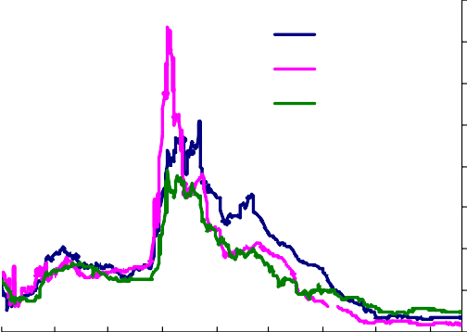

Sterling

US dollar Euro

350

300

250

200

150

100

50

0

Basis points 3500

3000

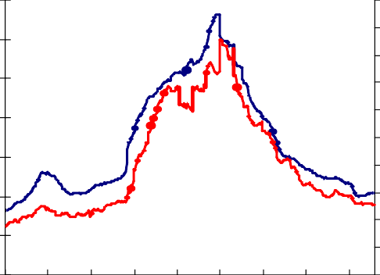

**Investment Grade (rhs)**

**Non-Investment Grade (lhs)**

2500

2000

1500

1000

500

0

Basis points

750

675

600

525

450

375

300

225

150

75

0

Jan Apr Jul Oct Jan Apr Jul Oct Jan 2008 2009 2010

*These are three month spreads.

Jan Apr Jul Oct Jan Apr Jul Oct Jan

08 09 10

Source Merrill Lynch: Option-adjusted spread over government rates. Investment grade refers to an index of bonds rated BBB3 or higher, and non-investment grade bonds rated lower than BBB3.

Chart 3 shows the scale of the collapse in equity prices, which was particularly sharp around the end of 2008, and continued through the first quarter of 2009. Between the summer of 2008 and March of 2009 equity prices in the UK fell by around 40%.

# Chart 3: UK Equity Prices

FTSE All Share FT SE 100

% change since January 2007

10

0

-10

-20

-30

-40

-50

2007 2008 2009 2010

What has happened since QE began? The cost of inter-bank lending has declined sharply, with Libor-OIS spreads falling to their lowest level since the beginning of the crisis. This is not surprising. QE has led to commercial banks holding substantially higher reserves at the Bank of England. Much greater liquid asset holding by banks have pushed down on inter-bank lending rates. The three month Libor-OIS spread has fallen from around 160 basis points at the beginning of the QE policy to just 18 basis points. A range of initiatives to support the banking sector will have helped to push down on these spreads, not least by reducing solvency concerns within the inter- bank lending market. But QE has played a role in providing additional liquidity.

There has been an unusually sharp recovery in asset prices. Both investment grade and non-investment grade corporate bond spreads have fallen to around one third of their peak levels of March 2009 (see Chart 2)2. UK Equity prices are up around 45%. Issues of debt and equity by private, non-financial companies (PNFCs) have been unusually high (Chart 4). But PNFC bank borrowing has been unusually low – indeed net bank lending to non-financial companies has been consistently negative. In aggregate PNFCs have issued more securities and reduced bank debt. In the absence of QE this adjustment might have been harder, and firms might have cut back on investment even more sharply to pay down bank debt. To the extent that QE has facilitated this adjustment it will have had little impact on the broad M4 measure of the money supply. But the counterfactual could plausibly have been fewer issues of corporate securities, a bigger fall in corporate spending and lower broad money.

2 Investment grade bond spreads have fallen from a peak of just over 700bps to around 225bps and non-investment grade from just under 3000bps to around 900bps.

Asset purchases are likely to have pushed up on gilt prices. The change in gilt-OIS spreads (which should remove the impact of changes in expectations of the path of Bank Rate) since early 2009 will in part reflect gilt purchases by the Bank of England. These spreads will also reflect a range of economic factors and financial market conditions, not least expectations of future gilt issuance by the Debt Management Office, intimately tied to the outlook for the public finances. Since QE began gilt-OIS spreads are close to 12bps lower on 3 year and 20 year bonds. They are little changed at 5 years.

# Chart 4: Gross Corporate Bond and Equity Issuance

**Chart 5: Gilt-OIS Spreads**

Cumulative Issuance since beginning of the year, (£bns)

60

**Equity Issuance in 2009**

**Bond Issuance in 2009**

Average 2003 -2008

Average 2003-2008

50

40

30

Basis points

150

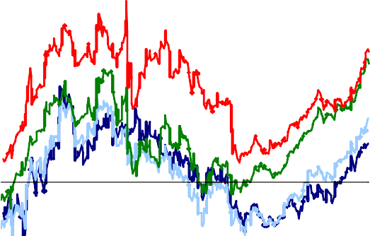

**20 year**

**10 year**

**3 year 5 year**

125

100

75

50

Jan Apr Jul Oct

20

10

0 Sep Nov Jan Mar May Jul Sep Nov Jan

2009 2010

25

0

-25

-50

How should we evaluate this set of financial market developments? If, one year ago, you had been told that the Bank of England would buy £200 billion of assets and that LIBOR, corporate bond yields, gilt prices, equity and property values, issuance of bonds and equities by financial and non-financial firms would evolve as they have, would you have thought that was a good outcome?

I suspect many people would answer that question with a yes, though a substantial proportion might say the good outcomes had little to do with QE. Their argument is that these positive signs would have happened anyway given that developments in UK financial markets are very similar to those in the euro zone and in the US. Furthermore, those central banks have not implemented a QE policy, so the impact of the QE policy has been negligible.

The part of that argument I find un-persuasive is the claim that the Federal Reserve Bank (Fed) and European Central Bank (ECB) did not do anything like QE. In fact both the Fed and ECB (along with many other monetary authorities) have expanded their balance sheets enormously. There are many similarities with the way in which the Bank of England’s balance sheet has evolved, and some differences (Chart 6). Chart 7 shows the asset side of the Bank of England’s balance sheet. As the Bank’s asset purchases have increased, they have offset the impact of the gradual withdrawal of emergency banking sector liquidity support (long-term sterling reverse repos).

# Chart 6: Central Bank Balance Sheets Chart 7: Bank of England Assets

Per cent of annualised nominal GDP

25

US

Euro area UK

20

15

10

5

0

Other assets

Longer-term sterling reverse repo Short-term open market operations Ways and means

Bonds and Other Securties

£ billions

350

300

250

200

150

100

50

0

2007 2008 2009 2010

Sources: Bank of England, Federal Reserve Board, European Central Bank.

2007 2008 2009 2010

The Federal Reserve balance sheet shows a rather similar picture; as emergency support for the banking sector has been withdrawn, the overall size of the Fed’s balance sheet has remained broadly stable as asset purchases have increased (Chart 8). The evolution of the ECB’s balance sheet appears at first to have been rather different to the Bank of England and Federal Reserve (Chart 9). As foreign currency lending to euro area banks by the ECB has been withdrawn, and shorter term operations have declined, longer-term refinancing facilities have been expanded. But outright asset purchases have been small.

# Chart 8: Federal Reserve Assets Chart 9: ECB Assets

$ bn

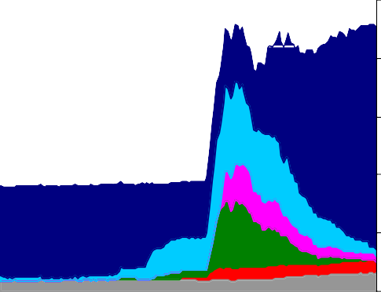

Treasuries, MBS and GSE debt Loans to financial institutions CP and ABS market support Central bank currency swaps Support for Bear and AIG Other

2007 2008 2009 2010

Sources: Federal Reserve Board

2500

2000

1500

1000

500

0

Covered bonds

Longer-term refinancing

Main refinancing operation

Foreign currency claims on the euro area Other

€ billions

2007 2008 2009 2010

Sources: European Central Bank

2,200

2,000

1,800

1,600

1,400

1,200

1,000

800

600

400

200

0

Have the Fed and ECB operated in a way that would have many of the same effects as QE? The Fed appears to have done a lot more credit easing – that is buying non- government bonds. But it has largely bought Treasuries and quasi Treasuries (agency debt mainly in the form of mortgage backed securities). The Fed expects to complete purchases of $1.25 trillion of agency mortgage backed securities and $175 billion of agency debt by the end of March 2010. In total these purchases will be equivalent to 10% of nominal GDP. Agency debt and Treasuries are likely to be very close substitutes – though the purchases of agency MBS might be expected to have a particular impact on the cost of new long-term fixed rate mortgages in the US.

The ECB has made hardly any asset purchases – though it does have a small covered bond programme3. It has undertaken a great deal of long term repos, in total close to

€660 billion, up by almost €400 billion compared with the level at the beginning of 2007. One can think of a long term repo as an asset purchase with a pre-announced exit plan. In that sense it is not so very different from QE. But it is different. Because the re-sale price is agreed up front the capital loss or gain element is absent. (But not entirely absent since there is counterparty risk and the collateral for the repo is most certainly not fixed in value). The Bank of England does face the potential for capital gains and losses in operating the APF, though this is in no way a measure of its effectiveness. The Bank does hold an indemnity from the government for any capital losses. The assets purchased are also predominately the liabilities of the government

3 The ECB has thus far purchased €35 billion of covered bonds, and expect to complete a total of

€60bn purchases. Covered bonds are collateralised debt instruments typically consisting of mortgages or public sector debt.

so the impact of capital gains or losses on the accounting position of the APF is very different from the effect on the financial position of the public sector as a whole. It would be hard for the ECB to have a similar arrangement because it does not have a single fiscal authority behind it. Another difference is that ECB operations are conducted with banks whereas the Bank of England has mainly bought assets from non-banks. But despite these differences I believe it is misleading to say the ECB has done nothing comparable in its likely impact to QE. And it is certainly wrong to say that about the Fed. So the conclusion that the common signs of recovery across financial markets in the US and euro area imply that the positive signs in the UK are unrelated to the QE policy seems to me to be incorrect.

What about the argument that QE has been ineffective – or at least very much less effective – because most of the assets purchased have been issued by the public sector and not the private sector? One way to put this is to say that in the UK we should have been doing more credit easing and less quantitative easing. I take this argument very seriously. My view is that ***if*** there had been no signs that the gilt purchases were helping reduce the cost, and improve the availability, of finance to the private sector then this would have been an argument with real force. But corporate bond spreads have fallen dramatically, absolute levels of corporate bond yields are down sharply, capital market issuance has been unusually strong, and LIBOR – a key determinant of the price of much of the bank lending to corporates – is sharply lower.

Another critique of the QE policy is that the weakness of broad money growth since the asset purchases began reveals its ineffectiveness. The annual growth of broad M4 money (excluding intermediate OFCs) has fallen to just 1.1% oya in December, and in the three months to December broad money had fallen by 0.5%. But as noted above, the QE policy can have beneficial effects even if the injection of additional money by the Bank of England does not, in the end, have much impact on the M4 measures of money. Two of the channels through which QE can work will not show up in broad money growth; when companies issue securities to pay off bank debt or when banks issue bonds and equity capital. Through both of these channels, the additional money injected by the Bank of England ends up alleviating credit constraints and improving the balance sheets of the banking system, but by doing so any impact on broad money as measured by M4 is obviated.

And we also need to think about the counterfactual. QE may well have significantly boosted M4 once you take account of other forces at work. That is not just a debating point. There have been significant equity issuances by banks that will have pushed down on the M4 measure of money growth4. Probably more significant is that the level of UK nominal GDP had fallen by 3.1% in the year to the third quarter of 2009. Assuming that, all else equal, broad money would move in line with nominal GDP that alone would have led one to expect a fall in broad money of over 3%. A more sophisticated calculation would take account of a wider range of determinants of broad money.

Chart 10 illustrates a simple counterfactual based on the relationship between broad money and nominal GDP during the last recession in the early 1990s. This shows that broad money might have been expected to fall by around 5% by the end of 20095. In fact it increased by over 1%.

# Chart 10: M4 less Intermediate OFCs Broad Money Growth

oya 20

% change

Nominal GDP

M4

broad money growth

counterfactual

15

10

5

0

-5

-10

1988 1992 1996 2000 2004 2008

The immediate effects of QE are on financial markets and financial flows. The feed through to private sector spending is likely to lag behind improvements in financial

4 For example, in December 2009 the Lloyds Banking Groups’ issued £13.5 billion issue of new shares, which will have pushed down on the M4 measure of broad money. The Royal Bank of Scotland’s

£25.5 billion share issue last year will also have reduced M4.

5 Between 1990Q2 and 1991Q2 annual broad money growth declined from 17.0% oya to 7.5% oya and nominal GDP growth fell from 10.0% oya to 4.5% oya over the same period. Given that nominal GDP

has slowed from 4.6% in 2008Q2 to -4.7% in 2009Q2 a commensurate fall in M4 growth (similar to the early 90s period) would lead to broad money growth declining to -5.5%. As noted above this is a simplistic analysis and a more sophisticated model of broad money growth would also include asset prices and interest rates.

market conditions. So less than a year since the beginning of the QE policy it is probably too early to have observed the full (or maybe even much) impact of asset purchases on the real economy. But by keeping stock of asset purchases in place one will be letting that play through.

The magnitude of all of the impacts of QE I have described here are – to a greater or lesser extent – subject to the difficulty of figuring out what might have happened had asset purchases been much smaller. Economic models can help here by trying to isolate the effect of other factors. In the Bank we do have a number of such models and they give a range of estimates for the overall impact of QE and of the time-frame over which the effects come through. That range reflects the inevitable uncertainty about the impact of a policy that is unusual in its scale and is being conducted in such a difficult economic environment. But those models do suggest to me that the impact of such purchases is very significant; it represents a very substantial easing in monetary policy which would, in more normal times, be the equivalent of a sharp reduction in the level of Bank Rate.

# QE as debasing the coinage

I noted earlier that there is a view that QE is necessarily inflationary. Must the creation of so much money be inflationary and take the rise in consumer prices to well above its target? I believe the answer is very clearly no. The view that it must be inflationary seems to me based on a set of implausible views about the economic situation, about the reversibility of QE and about how the MPC will react to it. There has been no change in the inflation targeting framework. It is by reference to inflation pressures that judgements on the scale of QE, and how and when it will be reversed, will be made. I see no technical problems with varying the stock of asset purchases – up or down – to hit the inflation target and no reluctance on the part of the MPC to do so.

Lowndes’ proposals to boost the money supply over 300 years ago was also denounced as necessarily inflationary. John Locke – one of the greatest thinkers of his, or any, day – argued fiercely and at great length that Lowndes’ proposal was an inflationary debasing of the coinage. The King and Chancellor sought advice on

Lowndes’ proposal from others. Sir Isaac Newton and Sir Christopher Wren were asked for their views. Locke, Newton and Wren represent a rather impressive council of wise men. I am not sure we could match them today.

Newton supported the analysis of Lowndes. But Locke’s view was given most weight. In some part this might be because he had as a young man conducted surgery on a previous Lord Chancellor (the Earl of Shaftesbury) and probably saved his life. Successful surgery in the seventeenth century was rare. That is the sort of thing that might count a lot to a King and his Chancellor in a tight corner in weighing up whose advice to follow on monetary policy. Locke’s advice was followed and when the coinage was re-minted there was not an adjustment to the official silver content of coins of a given face value. I believe this was a major mistake. The re-minting of the coinage was a huge drain on the public purse. By not boosting the money supply in the way Lowndes had recommended there came to be a further shortage of coin and this was a drain on activity. Lowndes’ plan for compulsory QE – making holders of tankards and plate exchange them for money – was not implemented.

So great were the costs of the policy that was actually followed, and so severe the pressure on the public finances, that a new tax was introduced the next year – the window tax. The tax was introduced under the Act of Making Good the Deficiency of the Clipped Money in 1696. This example of daylight robbery might have been avoided had Lowndes’ advice been followed.

# The policy issue today

There is no technical difficulty in altering the stock of asset purchases. And I believe the evidence suggests that altering the stock does have effects on spending and demand in the economy. So there are monetary policy instruments to use. That obviously does not make monetary policy easy – but it does mean it is important.

The February 2009 *Inflation Report* published a few weeks ago summarised the MPC’s collective judgement on the outlook. On the basis of an unchanged stock of asset purchases, and with Bank Rate following market expectations, inflation was assessed to be more likely than not to be above target for much of this year, then more likely than not below for it for next year. The probabilities of being one side or other

of the target level a few years down the road were seen as being almost equal (Chart 13). The probability distribution for the growth of GDP growth looks relatively strong in 2011 and 2012, judged by the standards of past average UK growth rates. But I do not think that this is a useful standard given the severity of the recession. I find the likely evolution of the level of GDP more revealing and that suggests that it is very *un*likely that output will return to the trajectory it had been on before the onset of the credit crisis. Even if the supply capacity of the economy has been significantly eroded by the financial crisis, there is likely to remain a substantial amount of slack in the economy.

# Chart 11: February 2010 Inflation Report Projection for GDP

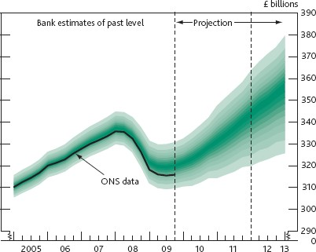

**Chart 13: February 2010 Inflation Report projection for CPI**

**Chart 12: February 2010 Inflation Report Projection for GDP Growth**

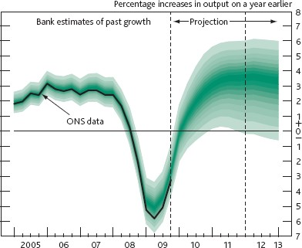

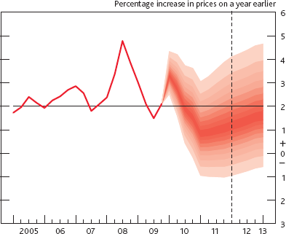

When looking at these charts it is very misleading to just focus on the path for outcomes that is seen as being the most likely. (The band containing the mode – the single most likely outcome – is the darkest band in the charts.) It is always a mistake to do that but particularly so when the mode is not the same as mean because of skew. Right now the charts have a large downward skew to GDP and at the same time a significant upside skew to inflation. This is unusual. Since the MPC began constructing its charts for probabilities the upwards skew to inflation has never been larger. The downward skew to GDP has only just fallen from its highest ever level in November – reflecting a belief that some of the worst downside risks have receded a bit.

This unusual setting for the assessed skews of risk is, I think, realistic. There are still more risks of growth not recovering to more normal levels than of substantially exceeding it. And around the most likely outcome for inflation – which moves from well above the target to below it – there are on balance a few more upside than downside risks. This is one of the reasons why the policy judgement is difficult and in my mind we should be ready to move either way. In judging which way to move it would, however, be a mistake to just focus on the most likely path – the single most likely outcome. That is not how any sensible person makes a decision in a situation of risk and uncertainty. It is not how the MPC should make its decisions. And it is not what we do.